**ASSIGNMENT 8**

Consider the informal specification of a simple library management system.

* Identify independently testable features.
* For each of the identified features, identify a method to generate test cases and justify your choice.
* For each of the identified features, derive a reasonable model. Briefly comment your choices when you have to complete the informal specification to produce the model.
* For each model, exemplify a possible functional test criterion defined based on the model, and exemplify two possible test cases derived according to the given criterion.

The **independently testable features** are:

1. **Registration system**: The library registration service allows people who would like to access the library services to register to the library system by providing the following information: name, contact address, resident address if different from contact address, nationality, date of birth, and e-mail address. If the nationality is Italian, the applicant can chose if to provide either passport number and expiration date or id-card number, expiration date and issuing town. If the nationality si not Italian, the applicant must provide passport number and expiration date. Applicants less than 18 years old must provide the following information about a parent or legal substitute of a parent: name, surname and library-id, if available, or passport number and expiration date, otherwise. The applicants shall indicate if they are registered to any other library in the national library system. If so, they shall indicate their library-id for the other registrations. If the provided information is valid and the applicant is registered to a national library system, the system confirms the library-id of the other library. If the provided information is valid and the applicant is not currently registered to any national library system, then the system checks for the existence of a prior registration: If the prior registration is still valid, then the system confirms the library-id. If the prior registration has expired, the system checks for the motivations: If the expiration is due to normal process (like the expiration after a given time of inactivity), then the system simply renews the library-id. If the expiration of the old library-id is due to bad behaviors (like books that were not returned yet), then the system denies the new registration. If there is no prior registration, the system issues a new library-id. If the provided information is valid and the applicant is registered to more than one national library system, the system signals the anomaly to the operator and holds the registration.
2. **Borrowing service**: The library borrowing service allows library-id holders to borrow books from the library. The service manages in parallel the state of the books and the state of the library-id holder. A book can be available for site inspection only or can be borrowed. If the book is for library inspection only, it can be available for inspection or be given to a library-id holder after a request for inspection. It returns in state available when the library-id holder terminates the inspection. If the book can be borrowed, can be in state available if it is in the library, can move to state requested due to a request, can become borrowed if the requested book is given to the library-id holder who requested it, becomes late if the library-id holder does not return the book before the deadline, and becomes available again when returned. A new library-id holder holds no books. The library-id holder can check if a book is available. If the book is in state available, and the library-id holder holds less than the MAX number of allowed books, the library-id holder can request the book; otherwise library-id holder cannot request the book. If requested, the book becomes borrowed. If the library-id holder returns a book and the book is in state borrowed, the book becomes available again and the number of books hold by the library-id holder is reduced by one. If the book was in state late, the book becomes available again and the library-id holder moves to a ticket state. The library-id holder goes back to a state where he holds the given number of books only when he pays that the ticket for being late. A library-id holder in ticket state cannot request books.
3. **Acquisition service**: The book acquisition service supports the process of buying new books for the library. The decision of buying the books depends on the value attributed to the book, the price of the book and the availability of a strong recommendation. The value of a books can be high, normal or low, depending on the topic, the author and the publisher. If the value of the book is high, the service acquires the book regardless of the price. If the value of the book is normal and the price is less than or equal to a given threshold TierN1, the service acquires the book. If the value of the book is normal and the price is between TierN1 and TierN2, the service acquires the book if there is at least a recommendation. If the value of the book is low and the price is greater than or equal to TierN2, the service acquires the book if there are at least ten recommendations. In all the other cases the service does not acquire the book.
4. **Storage service**: The book acquisition service stores acquired books according to the following DTD scheme:

<?xml version="1.0"?>

<!DOCTYPE bookstore [

<!ELEMENT bookstore (name,topic+)>

<!ELEMENT topic (name,book*)>

<!ELEMENT name (#PCDATA)>

<!ELEMENT book (title,author)>

<!ELEMENT title (#CDATA)>

<!ELEMENT author (#CDATA)>

<!ELEMENT isbn (#PCDATA)>

<!ATTLIST book isbn CDATA "0">

]>

The **models** that will be used are:

1. Registration system: **CFG** because there are different paths that can be covered depending on the information inserted by the user during the registration process
2. Borrowing service: **FSM** because the book have a finite number of states and determined action cause the transition to a different book state. The borrowing service manges multiple entity states that are book states just mentioned and the library-id holder states.
3. Acquisition service: **Decision table** because multiple boolean conditions are involved into the acquisition choice. The features described by this conditions have some dependecies between each other.
4. Storage service: **Grammar based testing** because is the most suited model for a DTD scheme

I will now **implement the models** just mentioned:

1. **CFG**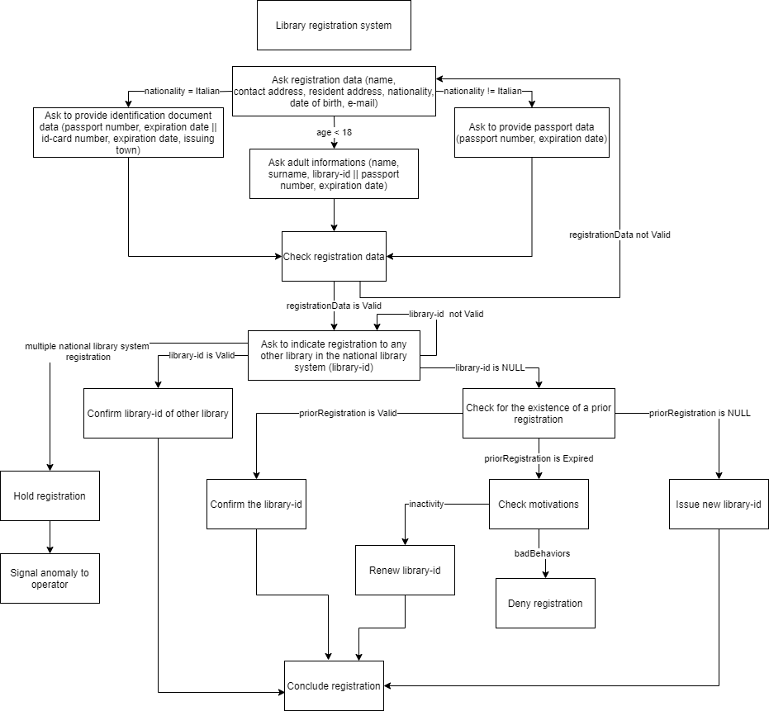

This CFG shows the possible paths that can be covered during the registration process and all the conditions that leads to them. Even if not mentioned in the informal specifications there were added some items in the graph to make the whole process logically complete:

1. A branch that leads back to ‘Ask registration data’ from ‘Check registration data’ if the data are not valid
2. A branch that leads back to ‘Ask to indicate registration to any other library…‘ from itself if the library-id is not valid
3. A conclude registration node that concludes the registration process if registration data are correct and a library-id is issued correctly
4. **FSM**

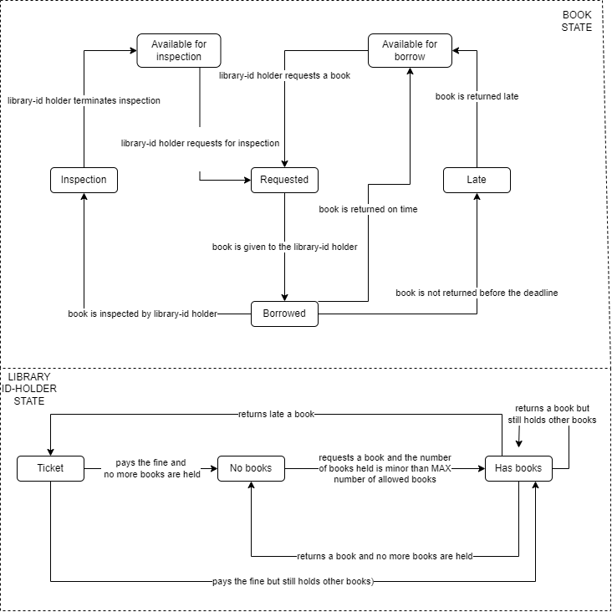

This FSM graph shows the possible states of books and library id-holder. Though books and library id-holder are not directly connected (this decision was made to inprove readability by reducing the number of transitions and removing shared states) in the graph it is obvious that the borrowing process includes transition of states of both books and library id-holder since they are managed in parallel.

1. **Decision** **Table**

Abbreviations:

* HV: High value book
* NV: Normal value book
* LV: Low value book
* P<=TN1: price is less than or equal to a given threshold TierN1
* TN1<P<TN2: price is between TierN1 and TierN2
* R: reccomendation
* P>=TN2: price is greater than or equal to TierN2
* A: Acquire the book

|  |  |  |  |  |
| --- | --- | --- | --- | --- |
| HV | T | F | F | F |
| NV | F | T | T | F |
| LV | F | F | F | T |
| P<=TN1 | - | T | F | F |
| TN1<P<TN2 | - | F | T | F |
| P>=TN2 | - | F | F | T |
| R= 1+ | - | - | T | T |
| R= 10+ | - | - | - | T |
| Out | A | A | A | A |

This table shows the possible combination of conditions that leads to a positive output (Acquire the book). As said in the specifications, in all other cases the service does not acquire the book (this cases are not represented to increase readability).

1. **Grammar** **based** **testing**

<bookstore> : : = <name> <topic+>

<topic+> : : = <topic> <topic+> | <topic>

<topic> : : = <name> <book*>

<book*> : : = <book> <book+> | <book> | EMPTY

<name> : : = String

<book> : : = <title> <author>

<title> : : = String

<author> : : = String

<isbn> : : = String

Using the models just mentioned i will now exemplify a possible **functional test criterion** and two possible **test cases**:

1. **CFG**: branch adequacy criterion. This criterion requires each branch to be traversed at least once by a test case. Since the assignment asks to generate only two test cases theese wont be sufficient to identify if the CFG fully satisfies the branch adequacy criterion. Following the test cases requested:

TC1:

Input: Registration of an Italian 27yo with multiple id-library accounts.

|  |  |  |  |  |  |
| --- | --- | --- | --- | --- | --- |
|  | Italian | Valid registration data | Multiple id-library | Hold registration | Signal anomaly |
| (1) | Yes | Yes | Yes | Yes | Yes |

The table shows the branch that are covered by this input.

TC2:

Input: Registration of a Spanish 16yo with a valid id-library account

|  |  |  |  |  |
| --- | --- | --- | --- | --- |
|  | Not Italian | <18 | Valid registration data | Library-id valid |
| (2) | Yes | Yes | Yes | Yes |

The table shows the branch that are covered by this input.

1. **FSM**: transition coverage criterion. This criterion requires each transition in a FSM to be traversed at least once. Since the assignment asks to generate only two test cases theese wont be sufficient to identify if the FSM fully satisfies the transition coverage criterion (which is satisfied). Following the test cases requested using abbreviations to identify the states (ex. AI = Available for Inspection, B = Borrowed)

TC1:

* Initial state: Available for inspection
* Input: Request for inspection by a library-id holder and restitution of the book
* T-Cover: AI, R, B, I, AI

TC2:

* Initial state: Available for borrow
* Input: Request a book which is borrowed and returned late
* T-Cover: AB, R, B, L, AB

To fully satisfy the transition coverage criterion two more test cases are needed which will cover the states of the id-library holder (has books, no books and ticket).

1. **Decision table**: MC/DC criterion. This criterion requires that each condtion must be tested at least once when True and once when False; also the values of theese conditions must effect the final output. Since the assignment asks to generate only two test cases theese wont be sufficient to identify if the decision table fully satisfies the MC/DC criterion. Following the test cases requested:

TC1:

Input: A high value book which is expected to be acquired independently

|  |  |  |  |  |  |  |  |  |  |
| --- | --- | --- | --- | --- | --- | --- | --- | --- | --- |
|  | HV | NV | LV | P<=TN1 | TN1<P<TN2 | P>=TN2 | R=1+ | R=10+ | OUT |
| (1) | T | F | F | F | F | F | F | F | A |

TC2:

Input: A low value book which is not expected to be acquired unless the price is greater than or equal to TierN2 and there are at least ten recommendations

|  |  |  |  |  |  |  |  |  |  |
| --- | --- | --- | --- | --- | --- | --- | --- | --- | --- |
|  | HV | NV | LV | P<=TN1 | TN1<P<TN2 | P>=TN2 | R=1+ | R=10+ | OUT |
| (2) | F | F | T | F | F | F | F | F | NA |

1. **Grammar based testing**: production coverage criterion. This criterion requires each production to be exercised at least once in producing a set of test cases.

TC1:

Input: A bookstore that has Horror and Sci-Fi topics

TC2:

Input: The books “It” by “Stephen King” and “Dune” by “Frank Herbert”